**CERTIFICATION MANAGEMENT APP**

PREPARED FOR:

CRM SFDC Training Program

Capgemini Technology Services

PREPARED BY:

Sanchal Shanu

46022661

MENTOR:

Rahul Vikash

**Abstract:**

The Certification Management App is a Salesforce application for managing certification process.

The Certification Management Application is a Salesforce-based certification manager. The basis of the project is to help keep track of the Employees' who have completed their certification. Also, here the app allows only 2 types of profile in this whole system, which includes the "App User" and the "App Admin". The App admin is the one who produces the Certifications and the Vouchers for them. The role of the App User is to add Employees and create Certification Request for these employees, which is further reviewed by the App Admin. The application also gives us information about the results of the Certification Exam for each Employee. Apart from this, the app includes Reports and Dashboards which helps us in compiling information more easily. The application likewise use the power of Lightning Web Components for building the UI for the application.

**Scopes:**

Inscope:

Following is the functionality provided by the application:

There are three categories of people who would access the application :

Two users which are App User ,App Admin and System administrator.

Each of them would have exclusive privileges:

1. The App User:
2. Perform CRUD operations on Employee and Certification request objects.
3. View custom objects: Certification and Voucher.
4. Can pass or fail the employee.
5. Reports and Dashboards.
6. The App Admin:
7. Perform CRUD operations on Certification and Voucher objects.
8. View custom objects: Certification Request and Employee.
9. Approve or Reject Certification Request.
10. Reports and Dashboards.
11. The System Administrator:
12. Creates users: app admin, app user.
13. Create profiles for users and controlling privileges.
14. Create custom objects Employee, Certification, Voucher and Certification Request.
15. Perform CRUD on custom objects.
16. Define the workflow and the approval process.
17. Can approve or reject the approval processes.

Outscope:

1. The following functionalities have not been covered under the application:
2. Third party applications like email .
3. The application does not include the Employee login

**Class Diagram:**

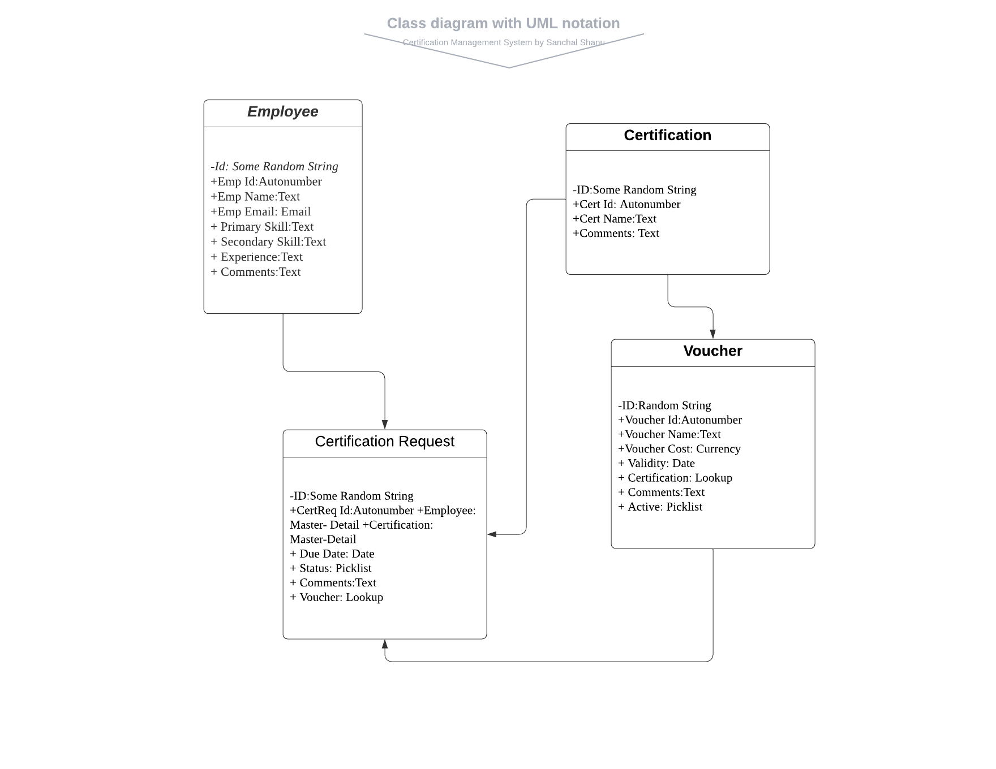

**Sequence Diagram for User:**

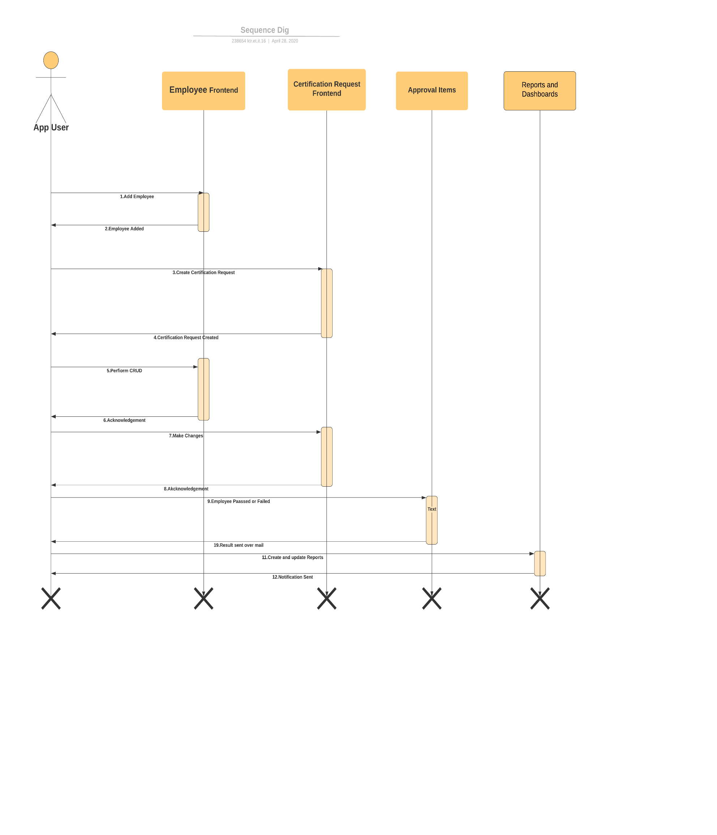

**Sequence Diagram for Admin:**

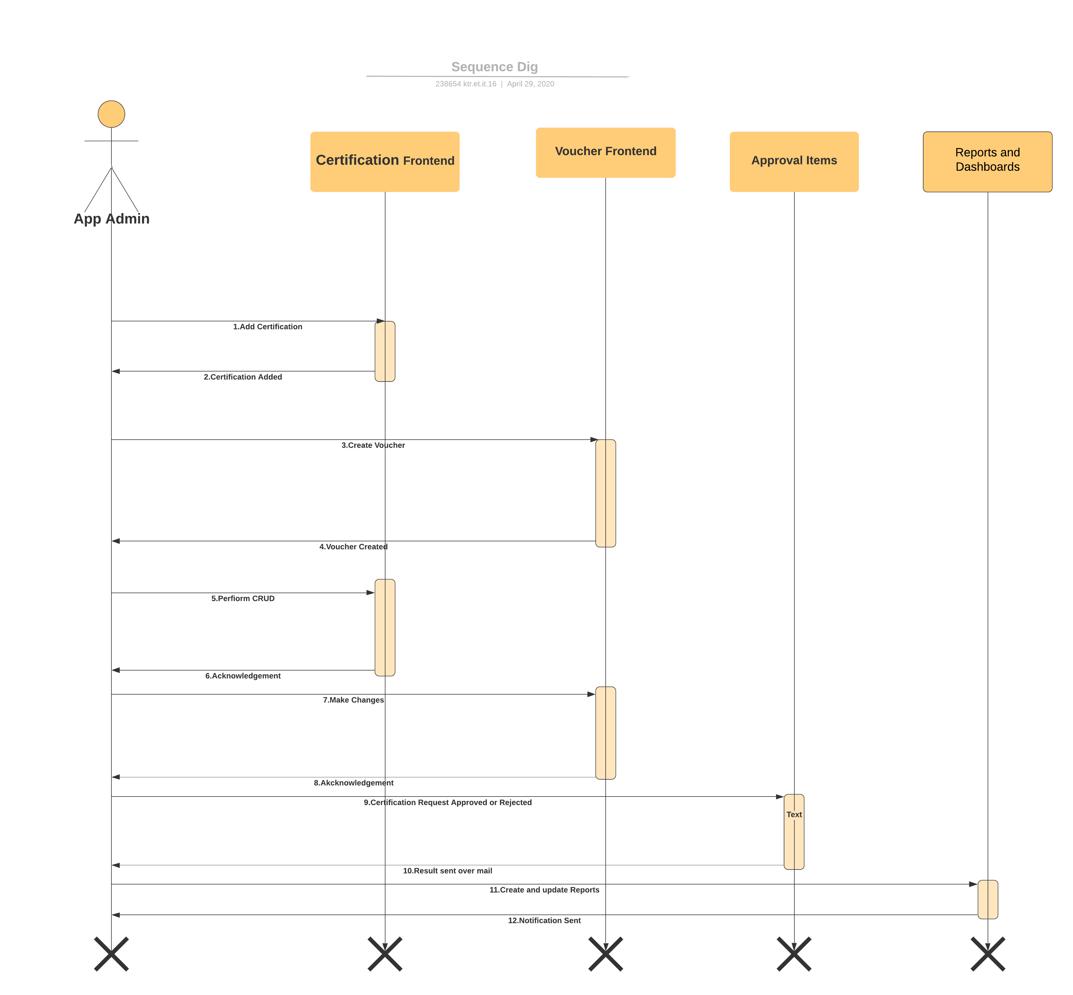

**Flow Chart:**

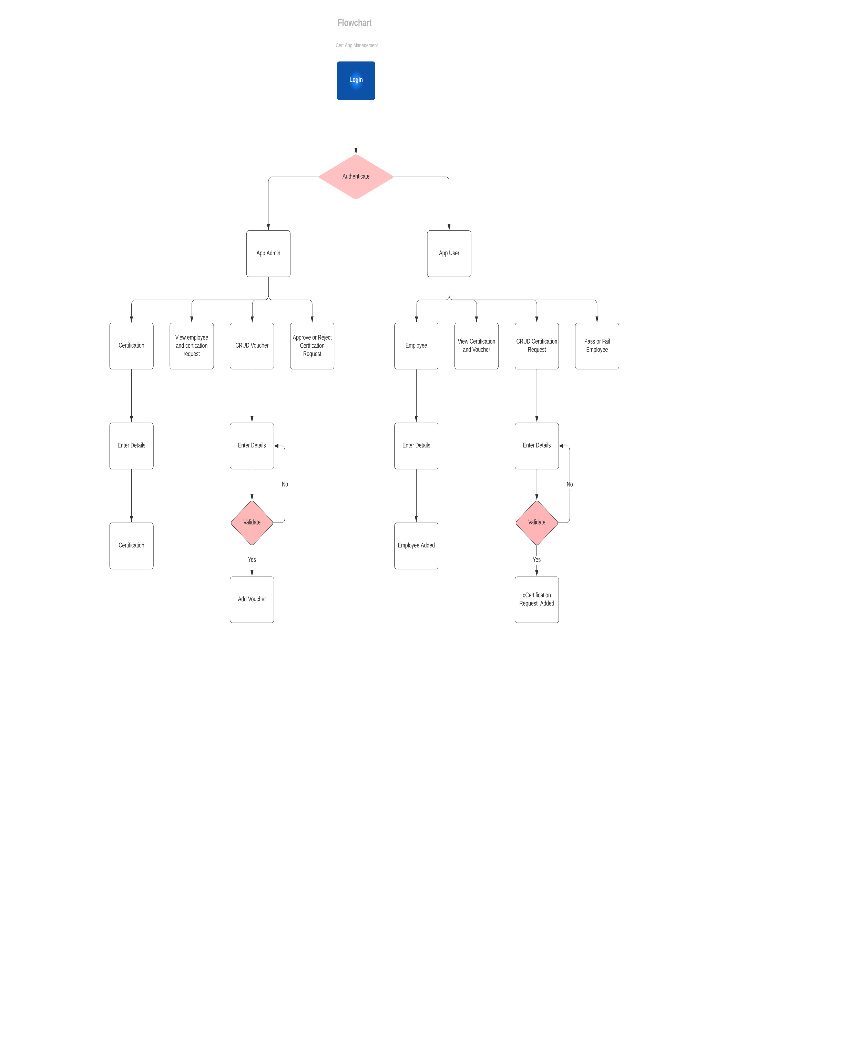

**Use Case Diagram:**

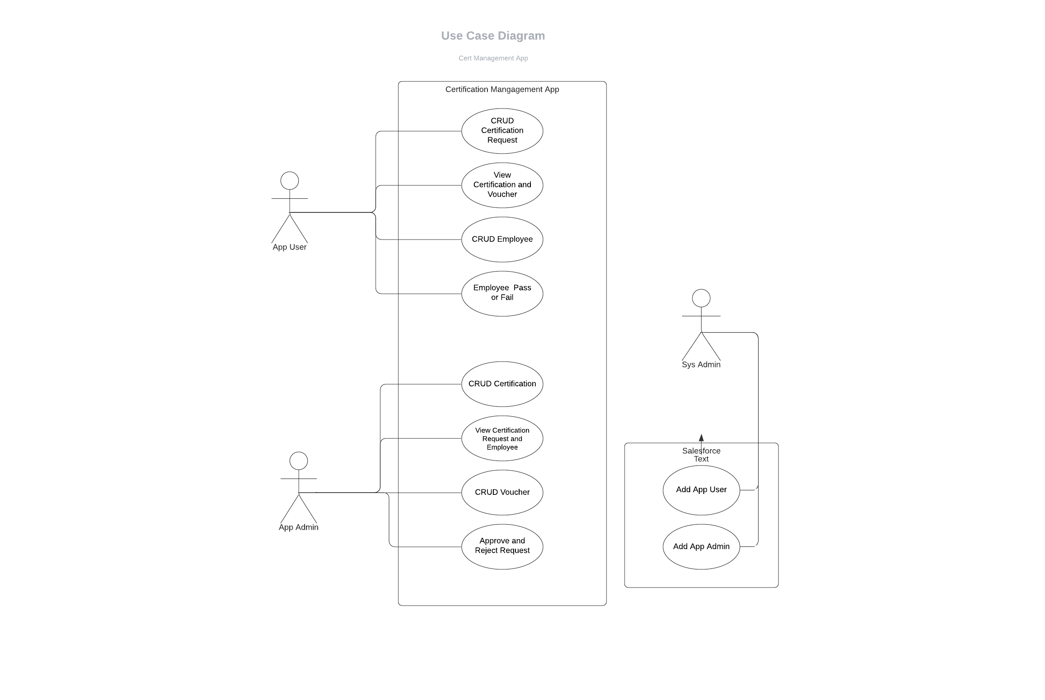

**Activity Diagram for Admin:**

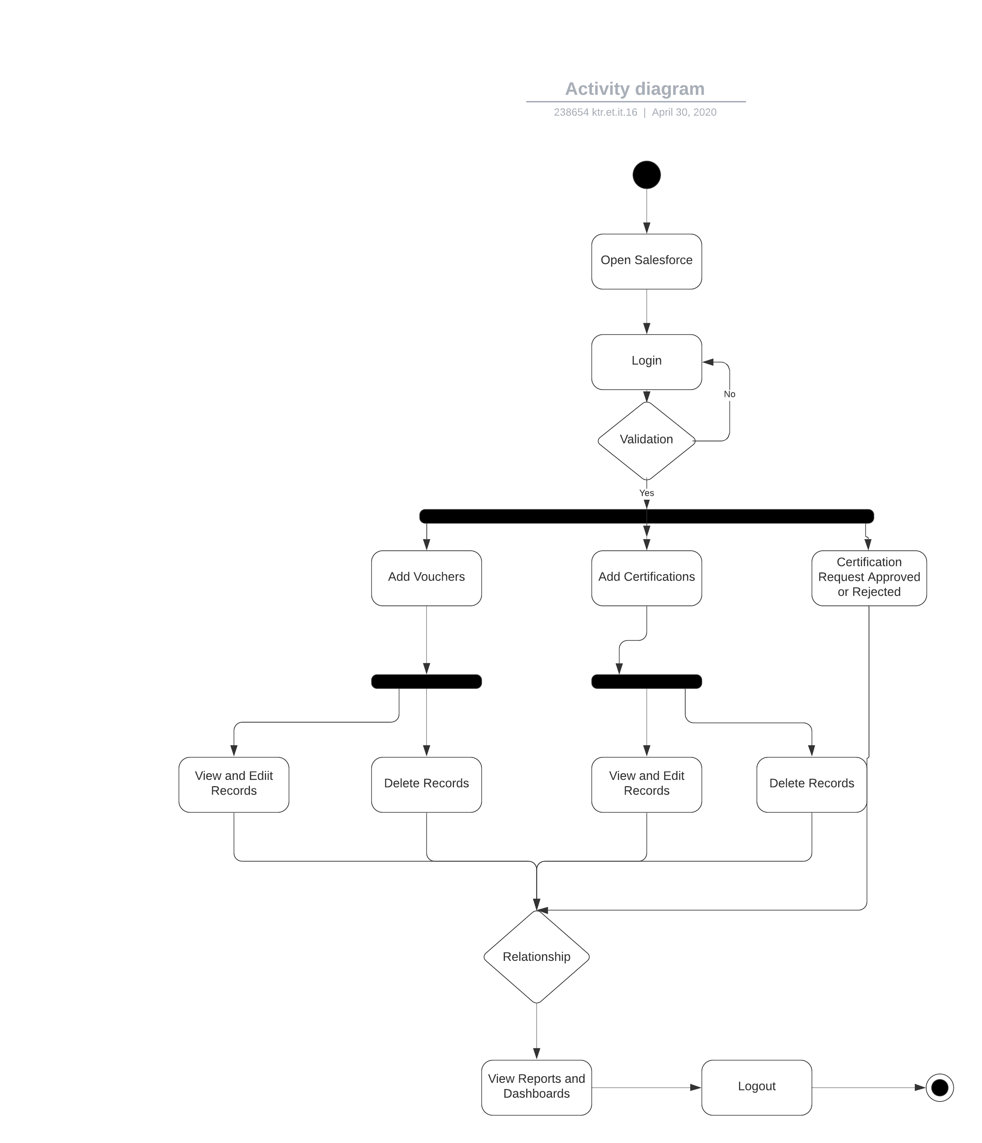

**Activity Diagram for User:**

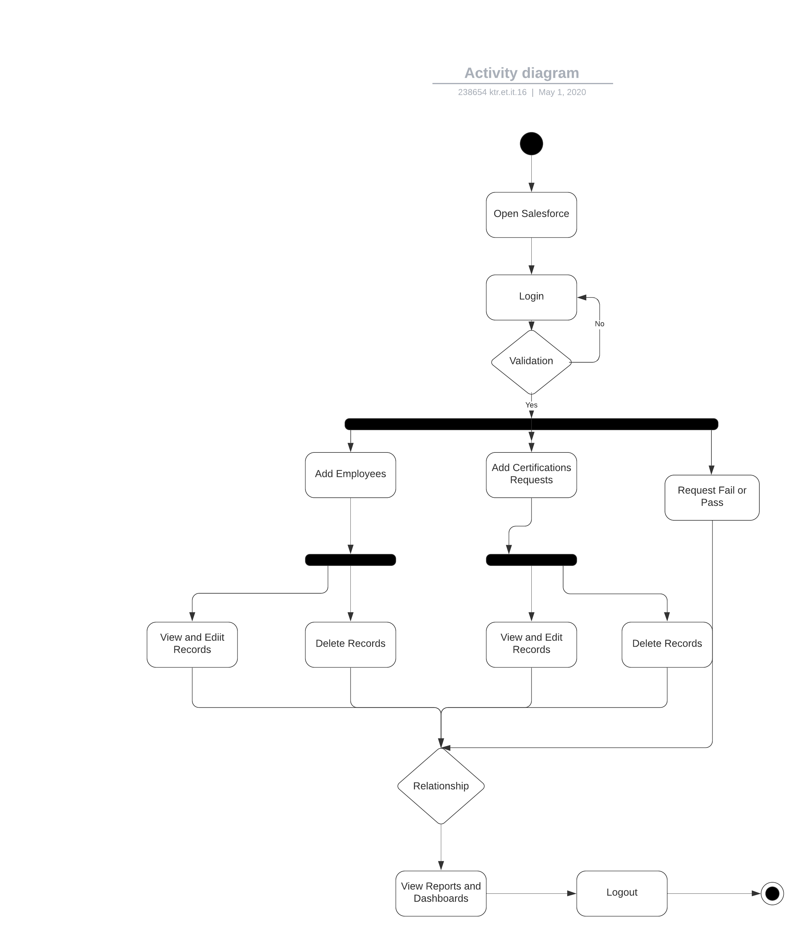

**Entity Relation Diagram:**

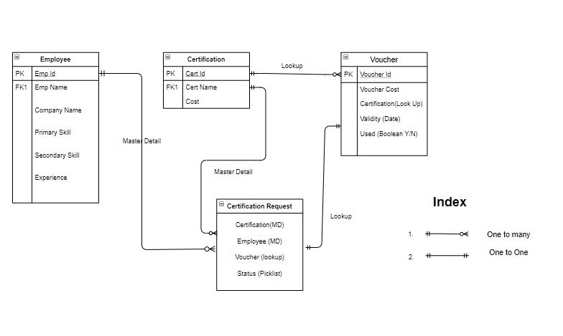

**User Interface:**

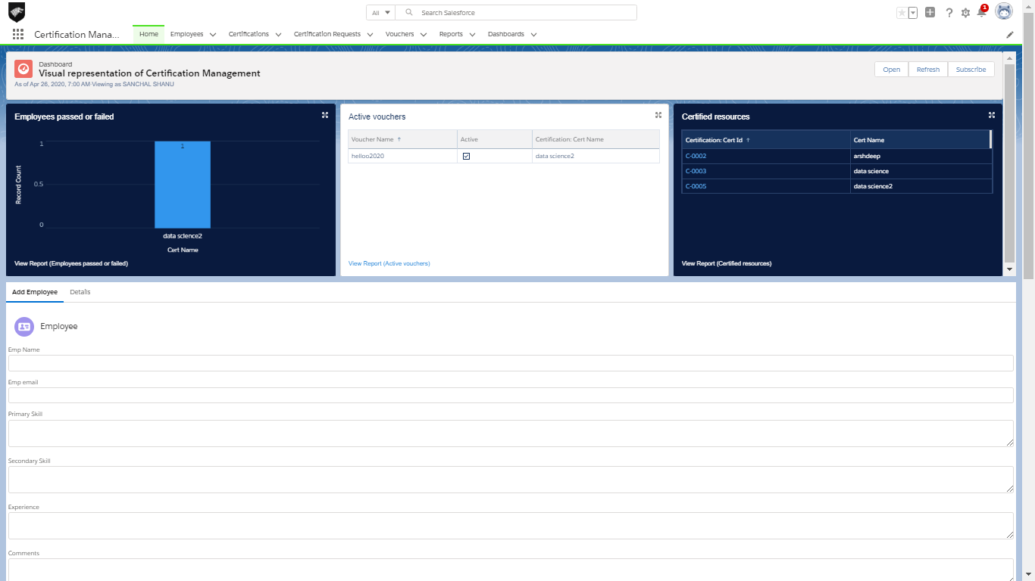

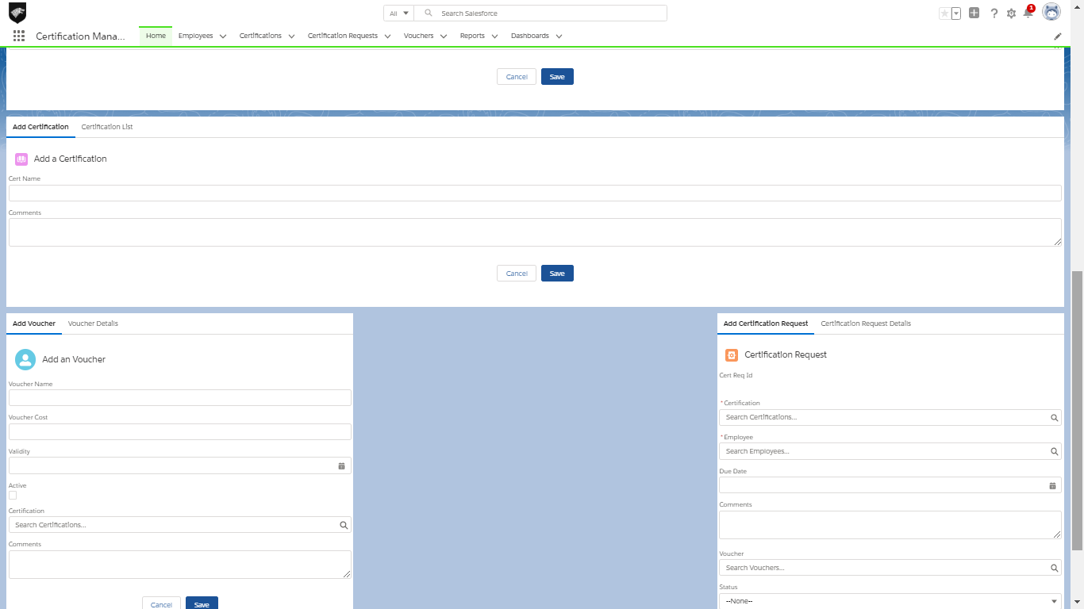

1. Add Employee

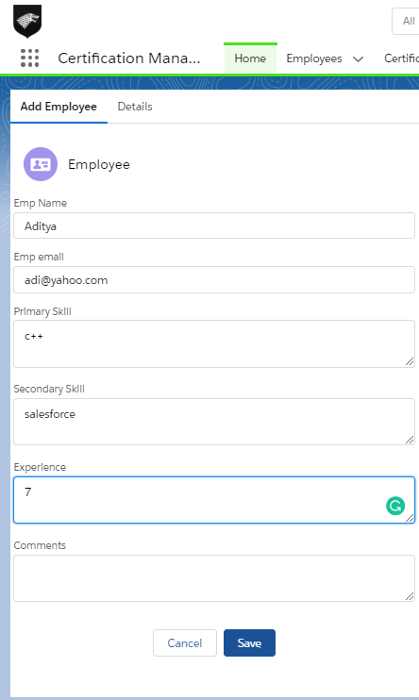

**2. Edit , Delete or View Employees**

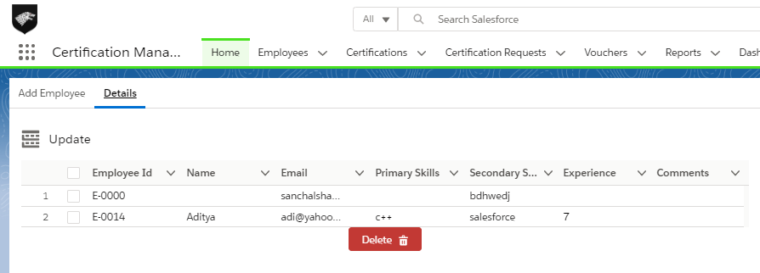

**3. Add Certification**

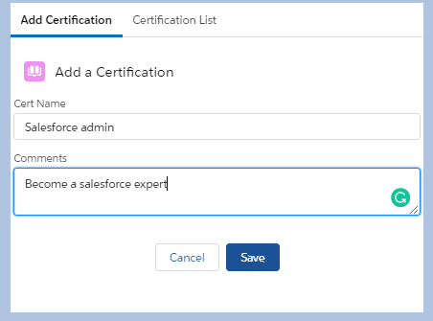

**4. Edit, Delete or View Certification**

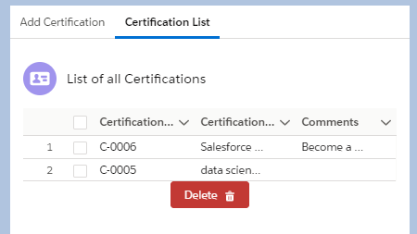

**5. Add Voucher**

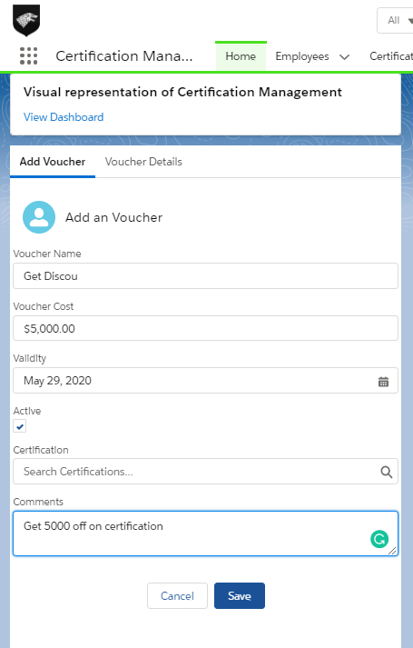

**6. Edit , Delete or View Vouchers**

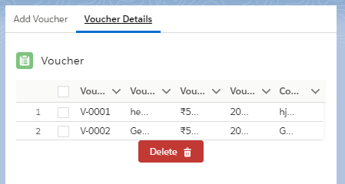

**7. Add Certification Request**

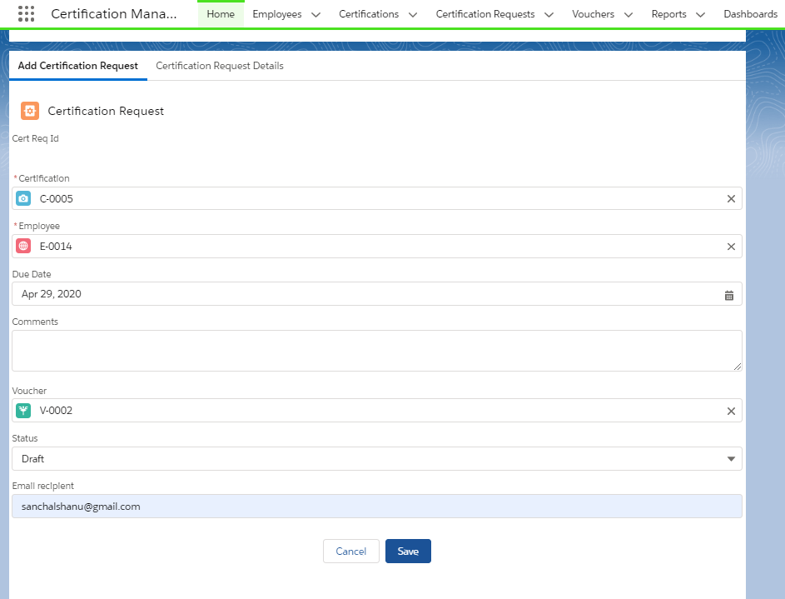

**8. Edit, Delete or View Certification Requests**

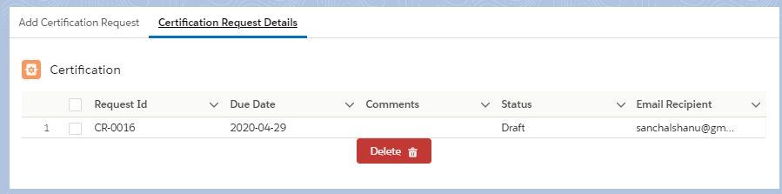

**Reports and Dashboard:**

**Reports:**

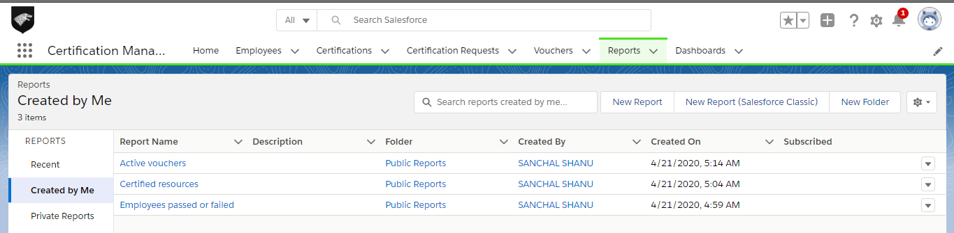

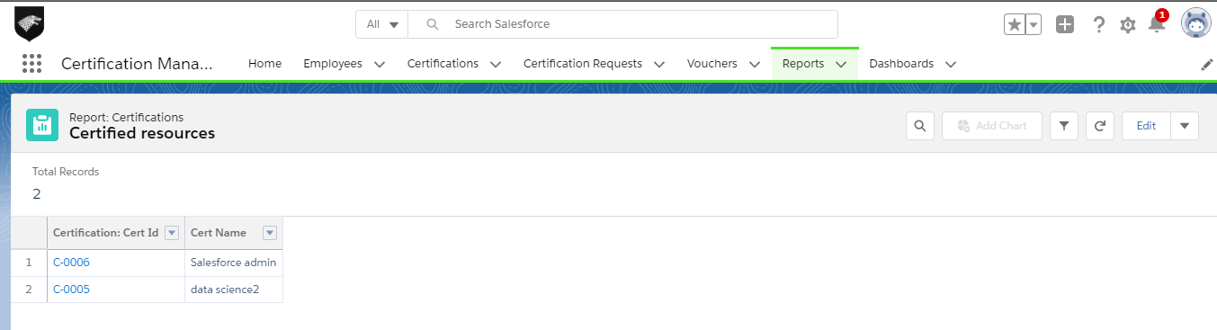

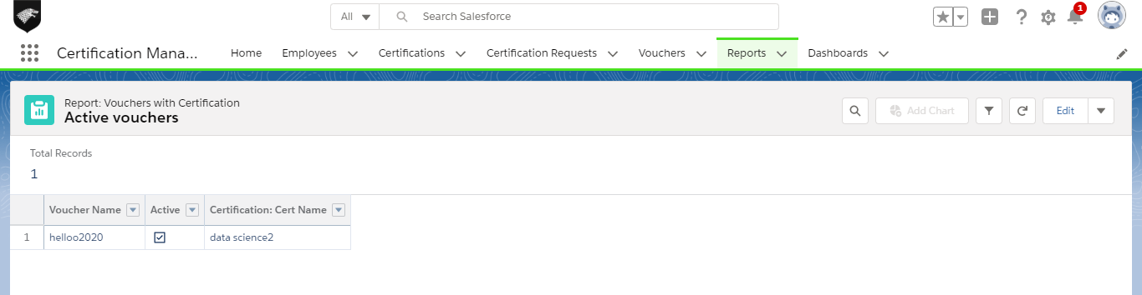

**Dashboard:**

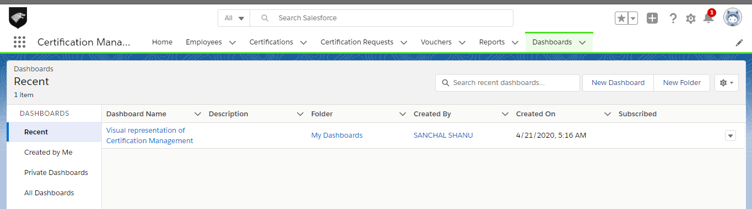

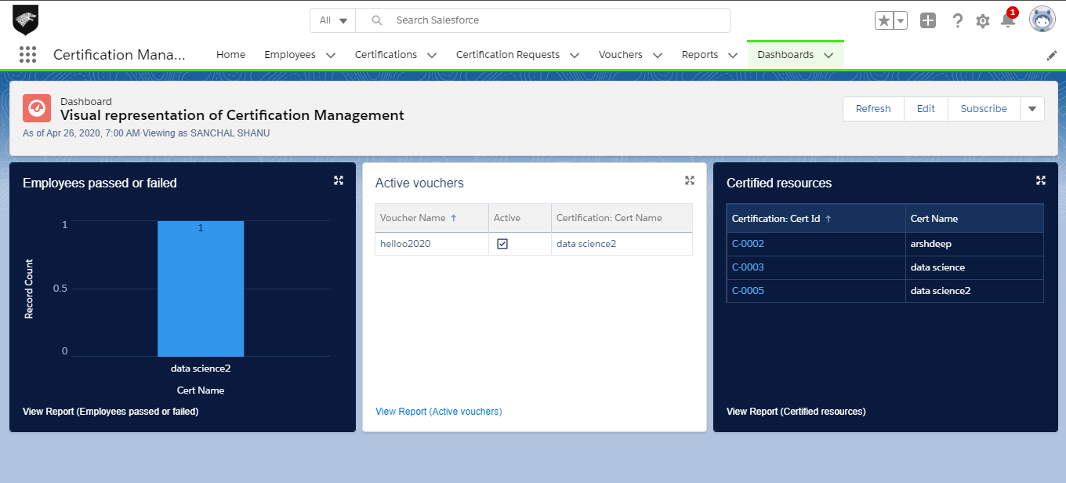

**Object and Fields:**

**1. Employee:**  This object is used to add data about employee.

Fields:

1. Emp Id: Auto Number
2. Emp Name: Text
3. Primary Skill: Text Area
4. Secondary Skill: Text Area
5. Experience: Text Area
6. Comments: Text Area

Validation Rules:

Triggers:

**2. Certification:**  This object is used to add certification details.

Fields:

1. Cert Id: Auto Number
2. Cert Name: Text
3. Comments: Text Area

Validation Rules:

Triggers:

**3. Certification Request:**  This object is used to add certification request of an employee.

Fields:

1. CertReq Id: Auto Number
2. Certification - Master-Detail Relationship
3. Employee- Master-Detail Relationship
4. Voucher- Lookup Relationship
5. Due Date: Date
6. Status -Pick list :
7. Draft
8. Approved
9. Rejected
10. Passed
11. Failed
12. Comments: Text Area

Validation Rules:

1. Same Voucher & Certification: used to match that voucher being applied is for correct certification.

Triggers:

1. Employee Duplicate : Checks if the certification request for the employee already exists.
2. Check Duplicates: Checks that the same certification and voucher details cannot be used again.
3. Automatically assign voucher: Is used to automatically assign voucher to a certification if certification is approved and voucher is not applied.

**4. Voucher:**  This object is used to add voucher details.

Fields:

1. Voucher Id: Auto Number
2. Voucher Name: Text
3. Voucher Cost: Text Area
4. Certification : Lookup Relationship
5. Validity: Date
6. Active: Pick list
7. Yes
8. No
9. Comments: Text Area

Validation Rules:

1. Name rule: Voucher Name should be exact 10 characters.
2. Validity rule: Voucher validity validation.

Triggers:

**Flow:**

1. Employee mails the app user to issue certification voucher.
2. App User raises the certification request to the App Admin who in turn approves or rejects the request. The request is raised using Approval Process tool of salesforce. The Approval Process is fired as soon as a request is created.
3. The Employee is notified when request is submitted by the App User via email.
4. The App Admin also receives a email when a request is raised.
5. If the App Admin approves the request, then, the employee and the App User receives a mail to tell them about the approval.
6. The voucher will assigned to the user when request is approved.
7. If the App Admin rejects the request, then, the employee and the App User receives a mail to tell them about the rejection.
8. The App Admin will provide some comments if the request is rejected.
9. The employee will notify the App User about the status of certification after the request is approved.
10. The App User will then change the request status to Passed/Failed based on the information provided by the employee.
11. In case due date of request is passed and request is still not approved or rejected, then, the employee and the app user will receive a mail to notify them to update the status of request.

**Assumptions:**

However, we have made a few assumptions with respect to the application, which are:

1. App admin and app user are two different users. It is system administrator who is performing the task assigned to app admin in order to avoid separate login during approval process.
2. Certification Request Status is changed to assigned only when it is approved not when voucher is assigned to the request.
3. Employee shares the status of the certification request with app user to get the status changed over email.